*Lab Sheet 7*

*Report*

Q1.

Polar Decomposition is Unique. This is because polar decomposition of a complex number is unique because clearly r = modulus of z and there is only one possibility of corresponding w(=cos(theta) + isin(theta)) .If z = x+ iy then r = sqrt(x^2 + y^2) and cos(theta) = x/r and sin(theta)= y/r. Hence, polar decomposition of z is unique, thus, polar decomposition of matrix is also unique.

Q2.

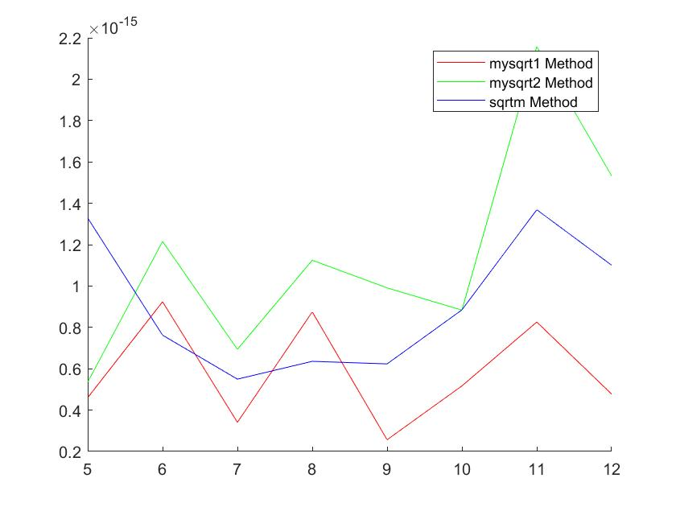

mysqrt2 shows the worst performance in all cases. sqrtm tends to show better performance that mysqrt1 around 6 and 8 but is poorer otherwise. Hence, it can not be said with certainty which method is better.

Q3.

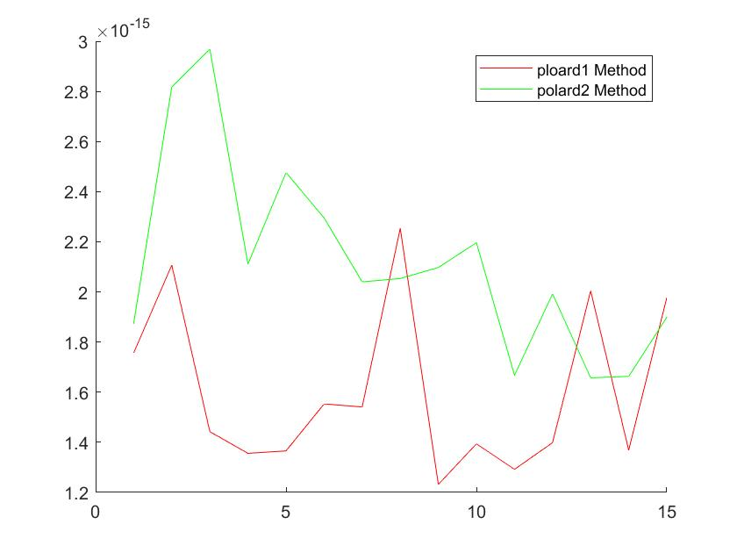

polard1 shows some peaks where its performance is worse than polard2.

However, in most of the cases, the norm of error for polard1 lies much

below polard2. Hence, polard1 is more reliable/better.

Q4.

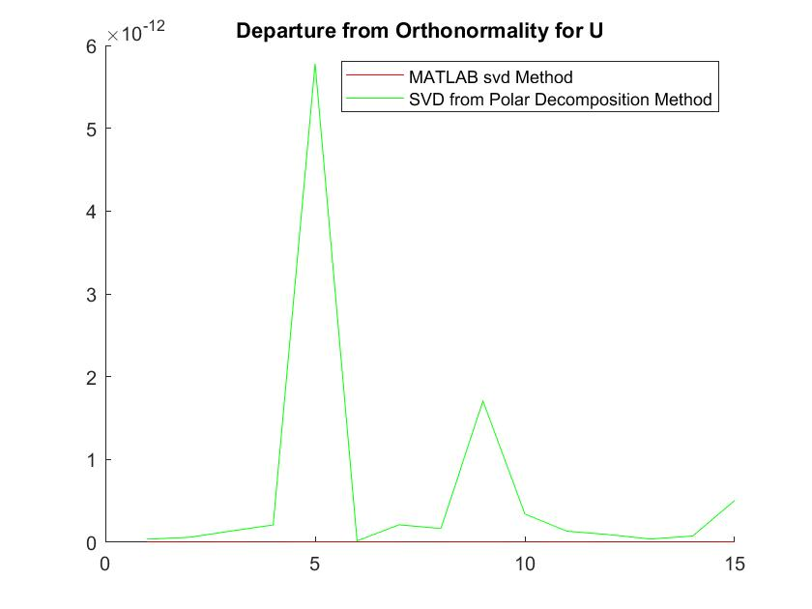

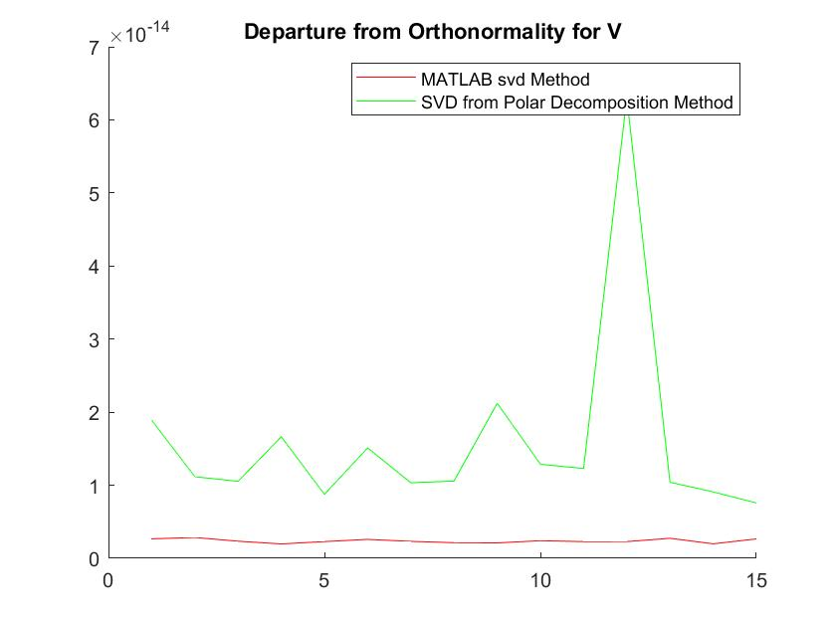

MATLAB svd method gives smaller departure from orthonormality values.

Hence, that is the more reliable method.